Sri Lanka Institute of Information

Technology



Lab Submission

<Lab sheet No 09>

**<IT24102722>**

**<Abesekara A.W.A.D.A.I>**

**Probability and Statistics | IT2120**

B.Sc. (Hons) in Information Technology

**Exercise**

**(1)**



**(i)**

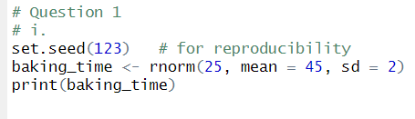

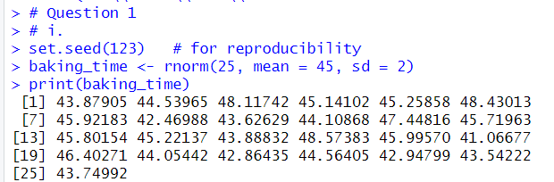

**(ii)**

